***Old project Evidence - Analysis/Design***

*Project proposal - pg1*

*Project plan outline - pg3*

*Project plan (****Gantt Chart)*** *- pg4*

*Feasibility study - pg6*

*End-user survey design - pg7*

*End-user survey analysis - pg8*

*Requirements Specifications - pg18*

*Test Plan - pg21*

**Project Information**

Project Criteria

-Project must include an interface appropriate for users

-Project must include input validation

-Project must include interfacing with files on client computers

-Project must include 2D arrays, arrays of records or similar

-Project must include recursion

Background

This project is being proposed as a two-dimensional platformer game. The main character will be a geometric fox-like character with the abilities to go up, down and sideways, as well as teleporting from platform to platform at a set length. The game will have an approximate 5-10 minute long tutorial, as well as 1-2 levels of platforming which include ‘enemies’ (NPCs) and various jumping puzzles. This game is a result of the SQA demand for a custom assignment worth 90 marks for an Advanced Higher Course. If the game were to be published, the end user group would most likely be made up of novice (and above) computer users that could fall into any age range. In particular, the computer users that would be most interested in this game would be people who are looking for something new to play and/or are looking for something original. Less able people/ people who struggle to use computers due to physical or mental disabilities will not be accommodated as there is not enough time to incorporate them within the time frame provided.

Objectives

-Game must have a full tutorial explaining how to move, jump, teleport and kill enemies with good set up examples

-Game must include a tutorial

-Game must have at least one level of platforming puzzles with enemies

-Game must be able to pause and unpause, and maybe save progress

-Main character must be able to move sideways, jump and fall

-Main character must be able to teleport to various points within the map

-Main character must have full animations for all of the above

Scope

The goal by the end of this assignment is to create a fun, 2D game, which can be played by most people and is able to achieve all objectives stated above (i.e main character able to move in all directions, teleport and play through various platforming puzzles and enemies, as well as the production of one or more levels of said platforming puzzles/enemies). Although, the game may not seem ‘finished’ and will most likely be a taster rather than a full game by the end of this assignment due to the time frame provided. Specifically, it must be created through methods which meet the SQA Advanced Higher Standards and satisfies the needs specified in the project criteria. The project criteria will be met through various techniques.

The project will include a menu when pausing and before the user starts the game in order to satisfy the need for an interface. If the input validation used when moving a character alone is insufficient, the tutorial will include a feature in which if a user presses the wrong button, a message will display. This will create overt input validation in the program. The game will also retrieve the username recorded on the PC and return it as the user’s name in order to create a more personable experience and fulfil the criteria of interfacing with stored data. The different types of enemies will be stored in arrays with various stats such as speed and health to create 2D arrays which fulfil the project criteria of 2D arrays. The enemies will have very simple artificial intelligence, which requires recursion in order for the enemies to move by themselves and without prompt. This will fulfil the criteria of needing recursion within the project.

There are little to no obstacles in creating this as we have the full software to create a 2D platforming game and submit it. The assumptions made are that we have the correct software available (and so will the clients) , the program will be run on either windows 7, 8 or 10 and the computer will have the correct hardware to run the game (including having enough RAM).

*Project plan outline*

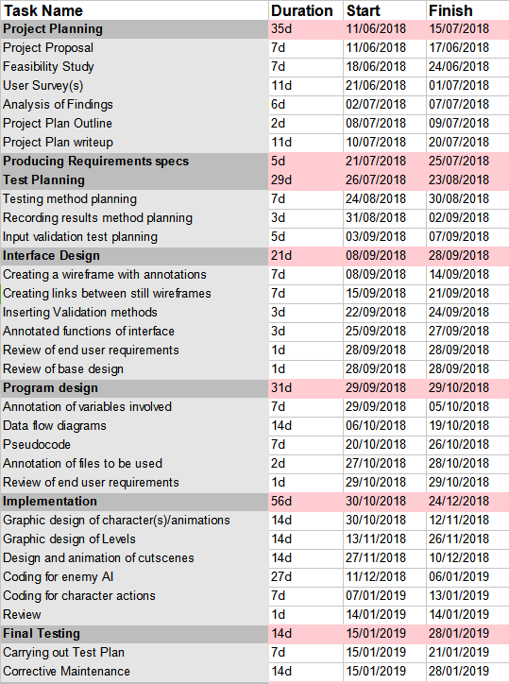

**Project Plan**

*Full project: 34wks*

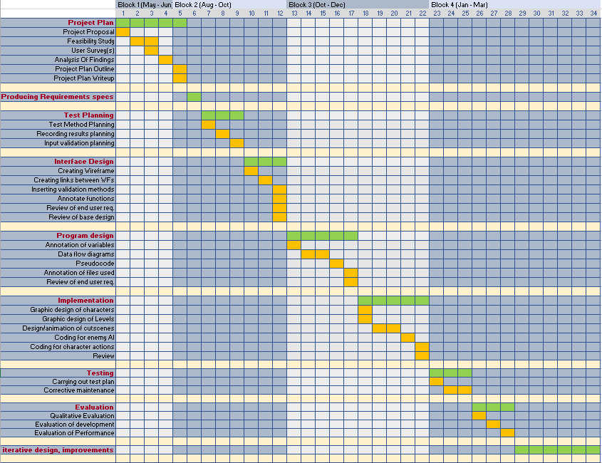

The previous page outlines the timeframes for the project. The project itself will last from 11/06/18 until approximately 19/04/19, although this is flexible based on when the SQA requests the assignment. In this time, each individual stage of the project has been separated into their individual timeframes and within these, their subtasks have also been separated into individual timeframes.

**Project monitoring and evaluation**

The project will be managed and monitored by a small record of progress, which includes reflective comments and evaluative comments on the quality of work within a session of work. This means that at the end of each working session, comments referring to quality of work, amount of work done and type of work will be recorded. As well as this, throughout the project, evidence must be recorded at each task and any changes made in an iteration must also be recorded.

**\*This project has been approved by a teacher but further information must be gathered using user surveys for a full outline of the project**

**\*Budget is not applicable to this project as all endeavours within this project have been fully funded by the school and any paid resources outside of the school were existent beforehand.**

***Feasibility study***

*Technical Feasibility*

The game itself requires a simple 2D game development software (such as GameMaker Studio), sound effect software, Writer and Spreadsheet software. GameMaker studio is installed on most computers being accessed to create the game, Audacity can be used to create sound effects and Microsoft Office can be used to create spreadsheets and word documents.

*Operational feasibility*

In terms of operating systems, the biggest problem we may have is making the game portable between windows 8 and 10. This problem can be fixed by compressing the game into a file type which is recognised and used by both windows 8 and 10.

*Schedule Feasibility*

As seen in the original project proposal, the project should take approximately 312 days, with an ability to lag behind by approximately 4 weeks. Although, it is not preferable if this happens. One of the issues (which we have already faced within the first few weeks of the project) is that if the developer (me) gets ill, then there is no one to fill in the space, so there is a large chance of getting behind.

*Market Feasibility*

The product being created is a 2D video game with a short and simple storyline. This type of game is already available on a worldwide scale and many examples can be found (such as Mario and Donkey Kong). However, I believe that I could create a charming and attractive twist on this typical genre, which would appeal to most people. What would make it unique would be its art style and characters, as well as a small amount of plotline.

There are not many development projects which offer a game about a non-humanoid animal-like creature and/or do not include any humanoid figures at all. This creates a unique dynamic and animation/art style which is not seen in many video games. Even the development projects which do exist with various animals involved do not seem to incorporate any kind of magical ability. Overall, this creates something new to be introduced to the market.

*Overall risk*

Some of the risks of this game include not finishing the game completely for whatever reason. Some of the reasons include: illness, other school subjects interfering, technical difficulties and equipment breaking or ceasing function. To reduce this risk, we must reduce the amount of backlog as much as possible. Although there is leniency to the amount of backlog we can have, there is a large risk of getting so behind that the project isn’t finished.

*End User Survey Design Questions*

***What do you want to find out?***

* How many people would enjoy this product?
* Would they prefer a pixelated or drawn look?
* Would they prefer an action based fighting system (e.g being able to attack with certain abilities) or a simplistic fighting system (e.g jumping on enemies to defeat them)
* What kind of hardware are they using?
* On average how many people play 2D platformers?

***Group of people to target?***

* Novice computer users
* Intermediate computer users
* Advanced computer users
* 13-18
* 19-30
* 31- 40
* 41-50
* 51+

***Number of people to target?***

20 + people

***How can a survey help me collect information for this problem?***

It will help me to collect information in order to figure out details of the project, such as the expected popularity of the end product and the undecided details which the end user group would prefer.

***Questions to ask?***

* Age group?
* Computer skill?
* How would you describe your computer’s performance?
* Have you ever played a 2D platformer game before?
* If so, what did you find most appealing about it?
* What did you find least appealing about it?
* If a new 2D platformer were to come out, would you prefer graphics that looked drawn or pixelated?
* Would you prefer the fighting system to be simplistic (such as jumping on enemies to defeat them) or more complicated (such as using certain allocated actions or items)?

***Survey form***

The survey will be in both digital and physical form depending on the way in which the person answering would like to answer. As well as this, the survey will be published online to Facebook in order to ensure both the largest and most diverse sample. It will also have a consent form, containing how the data will be used.

***End user survey analysis***

**Total number of physical form responses -** 45

**Total number of online form responses -** 61

**Total number of responses** - 106

*Question 1 - What is your age group?*

*Options:*

* <13
* 13-18
* 19-30
* 31-40
* 41-50
* 51+

*Number of people per option:*

**<13 -** 1 (0.9%)

**13-18** - 38 (35.8%)

**19-30** - 15 (14.2%)

**31-40** - 22 (20.8%)

**41-50 -** 21 (19.8%)

**51+**  - 9 (8.5%)

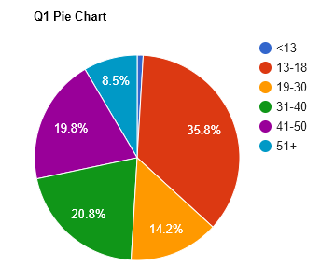

This shows that the largest group of people in the End User group are between the ages of 13-18. However, there is still a large chunk of people in most other age groups (apart from < 13 and 51+ age groups). This gives us an idea of our target audience.

*Question 2 - What would you describe yourself as?*

*Options:*

* A Novice Computer User
* An Intermediate Computer User
* An Advanced Computer User

*Number of people per option:*

**Novice -**  15 (14.2%)

**Intermediate** - 58 (54.7%)

**Advanced** - 33 (31.1%)

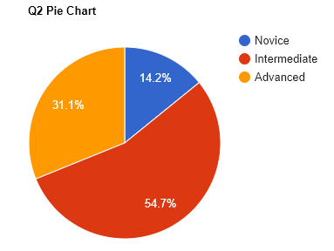

This shows that people within our end user group are a majority intermediate computer users. Therefore the installation process and options menu can be slightly more complex than that of a simpler game and slightly more simple than that of a complex game.

*Question 3 - How would you describe your computer’s overall speed/performance?*

*Options:*

* Low
* Mid-Range
* High

*Number of people per option:*

**Low -** 10 (9.4%)

**Midrange -** 59 (55.7%)

**High -** 37 (34.9%)

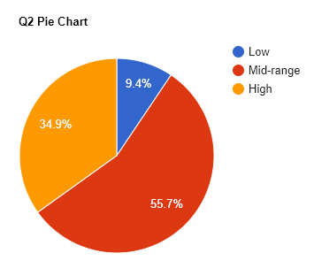

This data shows that the game we provide shouldn’t be too graphics intensive, as the majority of computers in the end-user group own a mid-range computer. Therefore, the game should be able to run on a mid-range computer.

*Question 4 - Have you ever played a 2-Dimensional platforming game before? (E.g. Mario, Donkey Kong, Manic Miner, Mega Man, Sonic, Thomas Was Alone etc.)*

Options:

* Yes
* No
* I don’t know

*Number of people per option:*

**Yes -** 103 (97.2%)

**No -** 2 (1.9%)

**I don’t know** - 1 (0.9%)

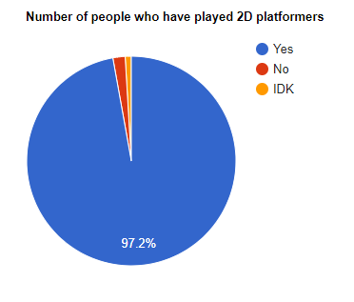

This data shows that almost everyone in the end user group has played the 2D platformer genre. This means that we are able to make the tutorial relatively simple as the user base has already experienced the general controls before.

*Question 5 - If so, what would you describe as the most appealing aspect of this genre? (Pick up to three options)*

Options:

* The Puzzles - I enjoy figuring out how to overcome obstacles
* The Enemies - I enjoy defeating enemies
* The Story - I enjoy a compelling plot
* The Art - I enjoy the art style of 2D platformer games
* Other… (Specify)

*Number of people who picked each option:*

**Puzzles -** 71 (36.4%)

**Enemies -** 31 (15.9%)

**Story -** 39 (20%)

**Art -** 38 (19.5%)

**Other -** 16 (8.2%)

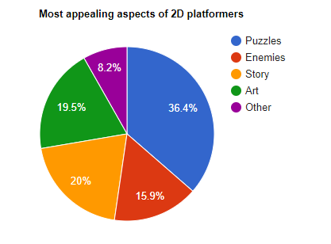

This shows that out of the defined options, puzzles are considered the most appealing. Therefore, throughout the creation of this game, we should focus on the puzzle aspect of the game.

*‘Other’ Comments:*

‘The movement’

‘Winning’

‘The emptiness after completion of the game so you can play again’

‘Everything’

‘The soundtrack’

‘The music’

‘The soundtrack, music and sound effects’

‘Mindless play’

‘Emotions’

‘Challenge to skills’

‘I enjoy the satisfaction of fast/effective traversal of stages’

‘Passes the time! (Not my favourite genre though)’

‘The pick up play-ability of the genre. ~It’s usually very obvious how to play the game. ~If it isn’t, it’s usually a badly made game’

‘The simplicity, the ‘pick up and play’ style and the inventiveness’

‘Mario is cute’

‘Ability to control people, god complex’

**Word cloud created from the ‘other’ comments, using** [**https://tagcrowd.com**](https://tagcrowd.com)

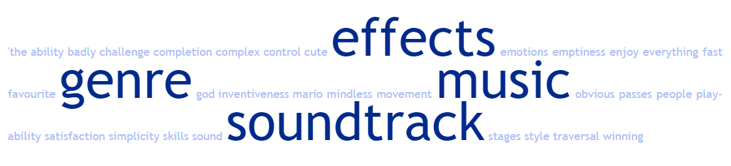

This word cloud shows that there is a frequency of comments concerning ‘effects’, ‘music’, ‘soundtrack’ and of course, genre. This means we may need to pay more attention to music and sound effects.

*Question 6 - What did you find least appealing about the genre?*

Options:

* The Puzzles - I dislike figuring out how to overcome obstacles
* The Enemies - I dislike having to defeat enemies
* The Story - I dislike a plotline
* The Art - I dislike the art style of 2D platformers
* Other… (Specify)

*Number of people who picked each option:*

**Puzzles -** 20

**Enemies -** 24

**Story -** 15

**Art -** 14

**Other -** 35

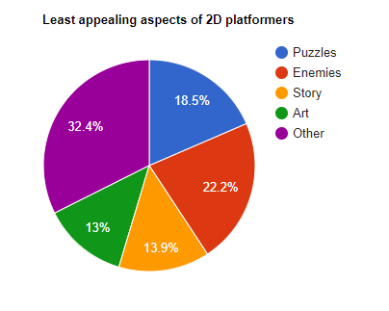

This shows that a large chunk of people dislike enemies in a game. This means that we may need to focus on client feedback throughout when designing the enemies in the game.

*‘Other’ comments:*

‘Gets repetitive’

‘Bad mechanics/gimmicks’

‘Moving things and taking jumps’

‘N/A’

‘N/A’

‘Nothing’

‘Nothing’

‘Nothing’

‘If it's just a genuinely bad game’

‘Bad 8 bit soundtracks’

‘Repetitive nature of some of the level design’

‘Basic’

‘First Person’

‘Single outcome’

‘Nothing’

‘Some levels are a bit boring but you have to do them to move onto next level’

‘I love all of these!’

‘Can’t always save progress’

‘Not being able to get to the end of the level’

‘Nothing’

‘Nothing specific!’

‘’

‘The camera angles’

‘Too many copy/paste games’

‘Being repetitive’

‘Pixel perfect precision to jumps’

‘Because game is 2D sometimes limited gameplay mechanics’

‘Levels not long enough’

‘Slow loading’

‘I don’t actually dislike anything there, but the story is least important to me’

‘Nothing’

‘A story used to explain the game and not part of the gameplay’

‘My inability to time jumps’

‘Compulsion to continue’

‘Reliance on mechanics that can be poorly implemented (e.g. wonky collision handling)’

‘Pixel perfect jumps’

**Word cloud created from the ‘other’ comments, using** [**https://tagcrowd.com**](https://tagcrowd.com)

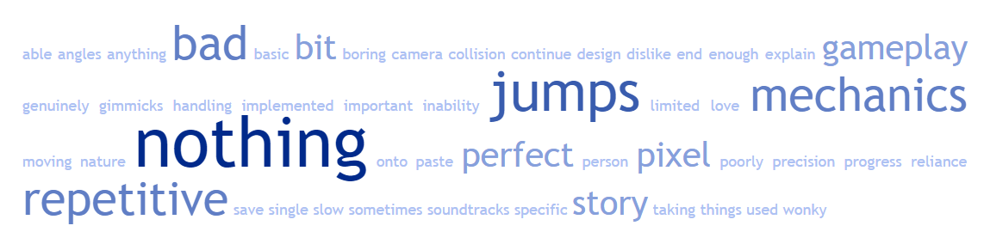

This shows that many people are concerned about the jumps, mechanics and repetitiveness of the game. Therefore we must focus on those three elements more, requesting client feedback throughout.

*Question 7 - If a new platformer were to come out would you prefer pixelated or drawn graphics?*

Options:

* Pixellated
* Drawn
* Other… (Specify)

*Number of people who picked each option:*

**Pixellated -** 39 (37.1%)

**Drawn** **-** 55 (52.4%)

**Other** - 11 (10.5%)

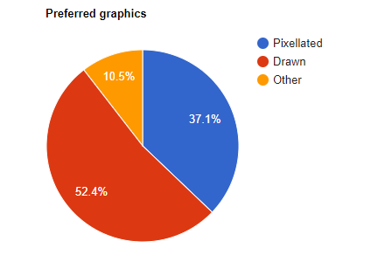

This shows that the overwhelming preference is for drawn graphics. This is most likely achievable as the software being used allows for both.

*‘Other’ comments:*

“Not bothered - would play!”

“VR”

“Depends on the plot”

“High standard CGI”

“Both”

“Don’t mind”

“I like both”

“Mixture of both”

“No preference”

“Vector line”

“Either”

“No preference”

Overall, these comments show that some people do not have a preference as to which type of graphics are used and others may want a combination of both drawn and pixelated graphics. There is still an overwhelming need for drawn graphics however so the project will be focused on that.

*Question 8 -Would you prefer the enemies in this platformer to be defeated simplistically (e.g: Jumping on enemies to defeat them) or with complexity (e.g: using certain items or actions)*

Options:

* Simplistic
* Complex

*Number of people who picked each option:*

**Simplistic -** 45 (42.5%)

**Complex** - 61 (57.5%)

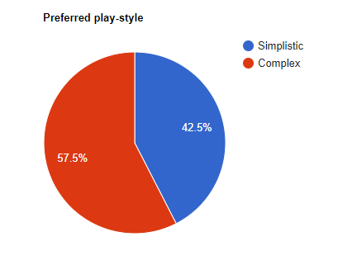

This shows that the preferred play style would be complex. Therefore there may also need to be an implementation of items or actions in order to cater to the end user audience.

***Requirements Specifications***

Scope

By the end of this project, this game should be a playable two dimensional platformer with at least two levels of platforming puzzles with enemies, the ability to pause, unpause and save, a main character that can jump, move sideways, teleport and fall as well as having animations for all of the above. The game will most likely not be a publishable game and instead will be a taster/beta model of a full game. However the developer must ensure that the game meets SQA Advanced Higher Standards and satisfies the project criteria of an Advanced Higher assignment.

The assumptions made when making this game include that the correct software will be available for both client and developer, the program will be run on windows 7, 8 or 10 and the computer will have the correct hardware to run said program. There are little to no obstacles to creating this in terms of budgeting and software for the developer to create this game.

Boundaries

As stated earlier, this game will most likely be more of a taster than a publishable game. As a result, the game will seem unfinished and the clients will not be able to play more than one or two levels by design. This is due to time constraints given by the SQA.

End user group

From the end user survey, we can see that our end user group are 13-18 year olds, which have:

* Intermediate Computer knowledge
* Mid-range computers
* Played 2D platformers before

As well as this, this game will be supplied to the SQA.

User Requirements

The user requirements are defined by both the SQA and the End user group.

The requirements defined by the SQA are:

* 2D arrays, arrays of records or linked lists
* Recursion (most likely fulfilled within enemy AIs)
* User Interface with input validation
* Interfacing with stored data

The requirements defined by the end users are evident in the end user survey. They are more guidelines than absolute requirements but it would be in the best interest of the developer to adhere to these requirements.

The requirements defined by the End User Group include:

* At least one jumping puzzle within the game
* At least one soundtrack within the game
* Comparable originality - originality will be discussed within the evaluation
* Drawn graphics
* At least one booster/item within the game

Functional Requirements

* There must be a main menu and ‘Esc’ menu
* The main sprite within the game will be able to move left and right dependent on input from the user
* The main sprite within the game will be able to jump when the user tells it to
* The main sprite within the game will be able to teleport short distances within the map when the user tells it to
* When the main sprite passes over a shining bit of floor, it will acquire a ‘booster’
* ‘Booster’ will make main sprite move faster when user tells it to
* The system will include a tutorial to be presented with the user to tell the user how to jump, move left and right and teleport the main sprite, as well as how to defeat enemies.
* The system will include at least one level of jumping puzzles including enemies
* The system will be able create and load save files.
* The system will be able to pause and unpause a game
* There will be at least 2 types of enemy sprite within the game
* One type will only be able to move left and right of its own accord
* The other type will be able to move left, right and jump of its own accord
* There will be at least 10 of these sprites littered about each level.
* The enemy sprites will disappear when the main sprite jumps on them
* The system will count and display number of deaths

Inputs/Outputs

* When the user inputs ‘a’ from the keyboard during a level, the main sprite will move left
* When the user inputs ‘d’ from the keyboard during a level, the main sprite will move right
* When user inputs ‘Spacebar’ from the keyboard during a level, the main sprite will jump
* When user inputs ‘Shift’ from the keyboard during a level, the main sprite will use its booster if it has acquired a booster. The booster will disappear.
* When the user inputs prolonged click accompanied with a movement of the mouse, the main sprite will teleport
* When ‘Play’ is clicked from the main menu starts the screen will output the first level or (Optional) a cutscene
* When the user inputs ‘Esc’ from the keyboard, the game will pause.
* When the user clicks ‘Quit’ in the ‘Esc’ menu, the game will return to the main menu
* When the user clicks ‘Quit’ in the Main menu the game will shut down
* When the user clicks ‘Save’ in the ‘Esc’ menu, the game will save the state
* When the user clicks ‘Continue’ in the Main menu the game will continue from the last save state
* When the user clicks ‘Restart Level’ in the ‘Esc’ menu, the game will return to the beginning of the current level

***Test Plan***

|  |  |
| --- | --- |
| **Things to be tested** | **How it will be tested** |
| Does the program have a main menu? | * When program starts, main menu should display |
| Does the ‘Play’ button in the main menu work? | * Press ‘Play’ button on screen * Program should start a cutscene or the first level |
| Can the main sprite move left? | * Input ‘A’ from keyboard * The main sprite should move left |
| Can the main sprite move right? | * Input ‘D’ from keyboard * The main sprite should move right |
| Can the main sprite jump? | * Input ‘SpaceBar’ from keyboard * The main sprite should jump |
| Can the main sprite teleport? | * Input a prolonged click from mouse, accompanied with movement of the mouse * Main sprite should move from the origin point of the mouse click to the end point of the mouse click |
| Can the game pause? | * Input ‘Esc’ from the keyboard * Game should pause and display a menu with ‘Continue’, ‘Save’ and ‘Quit’ as buttons * Press ‘Continue’ in menu * Game should continue moving |
| Can the game save? | * Press ‘Save’ button in ‘Esc’ menu * .sav file should be created |
| Can the game load? | * Press ‘Continue’ in main menu * Game should load last save file |
| Can the game overwrite a save? | * Press ‘Save’ button in ‘Esc’ menu after first save was successful * Press ‘Continue’ in main menu * Old save file should be overwritten, loading most recent save file |
| Does enemySprite#1 work? | * Move main sprite to area where first enemy sprite should be * Enemy sprite should be moving left then right after hitting a surface, then left after hitting another surface. |
| Does enemySprite#2 work? | * Move main sprite to area where second enemy sprite should be * Enemy sprite should be behaving the same as enemySprite#1, except it must be jumping at random intervals |
| Does movement tutorial work? | * Press play on main screen * Text box should display how to move main sprite left/right * Input ‘A’ or ‘D’ from keyboard * Text box should display how to jump * Input ‘Spacebar’ from keyboard * Text box should display how to teleport * Input teleport action from mouse * Text box should display ‘Well done!’ |
| Does enemy tutorial work? | * Let main sprite be ‘killed’ by enemy sprite, sending it back to the beginning * Text box should display explaining enemies * Main sprite jumps on enemy sprite, making it disappear * Text box displays saying ‘Well done! You have killed an enemy.” |

*Input validation testing*

|  |  |
| --- | --- |
| **Input** | **What should program do?** |
| On main title screen, click anywhere but the main button/ press any button on keyboard | Program should continue running as it did before |
| Briefly click somewhere on screen once in main game | Program should not do anything. |
| Press all buttons on keyboard apart from ‘A’, ‘D’ or ‘Spacebar’ once in main game | Program should continue running as it did before |